Georgia State Parks and Historic Sites
Weekend Summary
06.22.2020

Crowds:
- May visitation for the Division was 1,151,920, an increase of 125,081 or 12% compared to May 2019. A total of 30 Parks had higher visitation than last year. Many parks were 30% above last year and a few were significantly higher, the highest being 149%. Sites that had to temporarily limit day use access due to capacity include beach at Don Carter, beach at Tugaloo, Cloudland Canyon, Ft. Yargo, Red Top, Sweetwater, Tallulah Gorge, and Vogel.

- Golf Course activity continues to be high. This weekend was 48% over last year. Red Top Mountain experienced the most boating activity over the weekend. Mistletoe was busy at the boat ramp due people using the area for day-use activities which caused parking issues for boaters.

Staffing issues:
- As of Monday, the Division has 26 part-time and full-time staff out due to COVID-19 related reasons. A total of 42 Camp Host Units (approximately 84 people) have left due to COVID-19 and 39 units have been replaced. A total of 21 employees have tested for COVID-19 and 2 were positive, 18 negative and 1 is awaiting results.

Positives:
- Parks were very busy and most cottages and campsites were sold out all weekend. Overall, this weekend parks did not have to temporarily limit access as often as past weekends.
- Skidaway Island was featured in an article “The Best State Park Campgrounds in Each State” as the best state park campground in Georgia.
- The reopening of the playgrounds and resuming programs were well received by Park Visitors. Laura Walker had a busy weekend featuring a fishing rodeo which was supported by LED Sgt. Shipes. Panola Mountain State Park’s tree climbing program resumed successfully with social distancing practices in place.
- The critically endangered Dwarf PawPaw was confirmed by WRD’s Jacob Thompson at Crooked River.
- State Senator Brian Strickland visited High Falls.
- An article titled “Travel during COVID-19: Cool summer getaways in the South where you can practice social distancing” ran in USA Today, which has a circulation of 74,453,222, on June 16th on Cloudland Canyon.
- Website statistics continue to be high. This past week total Pageviews were up 71%, Reservation pageviews were up 43% and the Alerts Page received 16,099 views.
- Even through the challenges of COVID, RMU was able to complete PRHS Mission related work. So far, there have been 26 burn operations on 733 acres in the north and 815 acres in South Georgia.
Mistletoe Panola Tugaloo
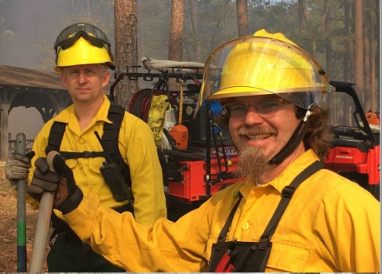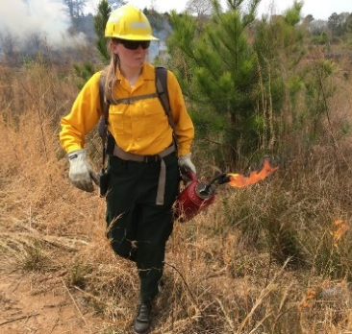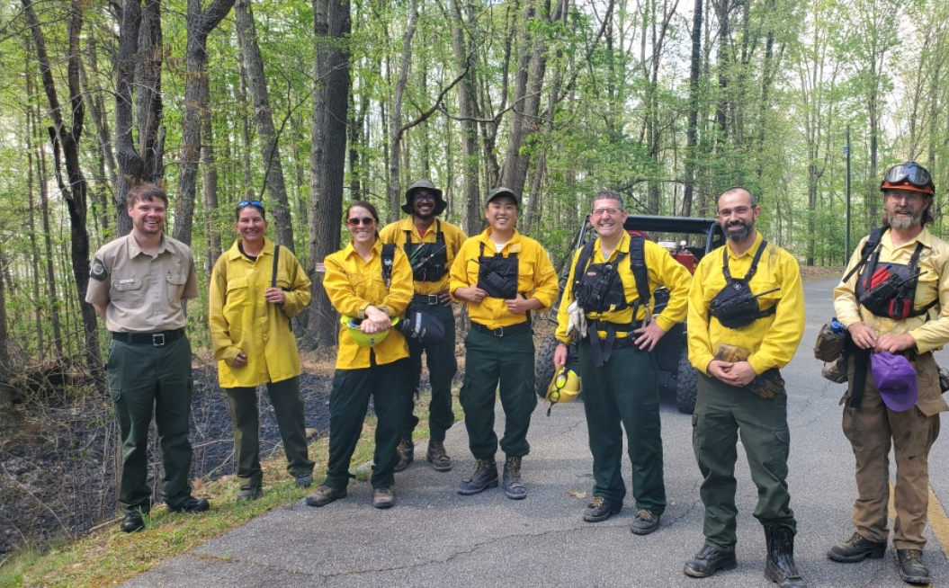

Challenges:
- At Red Top, there was a drowning incident on the lake requiring local responders and LED to use the visitor center parking area as a base of operations to expedite the emergency.
- Sites continue to struggle with filling part-time positions, including Housekeeping positions. Cottage turnovers are increasing with more one-night stays. The extra cleaning due to COVID-19 also continues to be a challenge. Sites are utilizing Maintenance Staff and Volunteers to meet the needs. Busy sites are experiencing excessive ground litter due to the crowds visiting the day-use areas.
- Several citations written by LED at Tallulah Gorge related to no gorge floor permits.
- Wormsloe was busy and experienced challenges managing visitor flow through the museum area.
- As is typical this time of year in South Georgia, many sites are struggling to fill host vacancies.
- General Coffee dealt with noise and occupancy issues with graduation parties in the picnic shelters.
- Fort Yargo and Red Top reported dealing with disgruntled guests due to capacity limits over the weekend.

Financial Update
Past Weekend:
Our overall occupancy for all reservables increased 9% this past weekend to 77%. Camping increased 12%, reaching 88% occupancy. And yurts were at 99% occupancy, 12% higher than the previous year. Cottage rentals had a slight increase going from 86% to 87%.
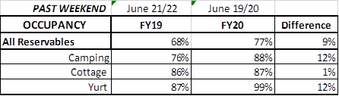
Upcoming Weekend:
For the upcoming weekend, there is a 5% increase in all reservables at 73% occupancy. Camping is showing a 9% increase, while yurts are showing a 3% increase to 100% occupancy. Cottages are showing a 1% decrease down to 85% occupancy.
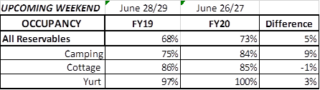
Revenue:
Year to date thru June 21st, park receipts have increased 8% or $2.3 Million over last year. This past week, June 15th – 21st, there was a 23% or $215,000 increase in overall revenue including ParkPass. Park receipts alone increased 53%. This is the 10th week in a row revenue has increased since COVID began.

For overnight accommodations – camping revenue continues to significantly increase. This past week camping improved 63% or $155,000. Cottages also had a significant revenue increase this past week increasing $125,000 to $358,000 for the week; yurts improved 19% or $3,000.
This past week, ParkPass revenue increased 18% or $24,000 compared to last year.
Golf was up 48% this past week or $22,000.
As we began a full week of the re-opening of the Historic Sites, Historic site admissions did decline in comparison to last year, but only by 5% or $2,000.
The revenue continues to significantly improve over last week due to several reasons:
- In early April we changed policy from collecting only a one-night deposit when booking a reservation, to collecting all revenue at the time of booking. This is the reason for the significant increase to camping, cottage and yurt revenue. This will have an effect on future revenue collections and the amount of refunds given.
- Camping occupancy has actually improved over the previous year for the 10th weekend in a row. And cottage and yurt occupancy are similar to where they were in previous years.
- And again, the number of cancellations is starting to significantly slow down. Although we do need to keep in mind, that for future refunds, we will be refunding the revenue for the entire stay, rather than just a one-night deposit.

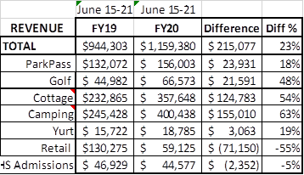

Cancellations/Refunds:
Through this morning, there have had 33,000 reservation cancellations, including $2.9 Million in actual refunds and a loss of future revenue of $12.9 Million. This is 1,000 more than last Monday, when there were 32,000 cancellations. The significant drop in the number of cancellations continues, as initially there were 4,000 – 5,000 a week, although there continues to be a higher number of cancellations than the previous year. Last year during the same week there were 690 cancellations, thus there were 310 more cancellations this past week than last year during the same time period.
Last year during March thru YTD, there were 12,800 cancellations, including $659,000 in actual refunds and a loss of future revenue of $3.1 Million. So, total cancellations have increased over 20,200 or 158% and the amount of refunds have increased $2.25 Million.

